Analysis Tower Bts Sst 4 Leg Angular 42m Due To Extend and Additional Antenna Load
(Case Study of The Semayap Kotabaru Location)

Arif Johansyah, Agyanata Tua Munthe
Faculty of Engineering
University Mercu Buana Jakarta, Indonesia
arifjohansyah86@gmail.com, agyanata.umb@gmail.com

Abstract

In BTS tower planning, the load that affects is the tower load itself, live load and lateral (side) loads that have a dominant effect is wind loads, because wind loads have high sensitivity to steel construction buildings (have a mass that tends to be light). Wind loads are calculated according to the Telecommunications Industry Association and Electronic Industries Alliance (TIA / EIA) standard structural standards for steel antenna tower and antenna supporting structure (TIA / EIA-222-G, 2005). The analysis uses the MS Tower V6 program, as an application to simplify telecommunication tower modeling. The purpose of this paper is to find alternative tower reinforcement so that it can withstand additional loads, be it additional loads due to extend and additional loads due to the proposed antenna.Based on the analysis results, the existing tower is still safe with a ratio of 0.345 <1, but the tower with an additional height and additional load of the antenna is not safe with a ratio of 1.189> 1, and the tower after being strengthened on the tower leg with a height of 0m-36m is done with STA (Star Angle) . And for reinforcement for leg towers at a height of 36-40m, it is done by adding the redundant member to the tower ratio to 0.689 <1, which means it is categorized as safe.Analysis with operational wind load (84km / hour), the reinforcement tower can withstand a maximum twist of 0.3436, a maximum sway of 0.0413, a maximum displacement of 0.1402.

Keywords
Analysis of Tower Structures, Extend Tower, MS Tower, Strengthening Tower, Tower BTS

1. Introduction
The development of telecommunication technology in Indonesia is increasing rapidly, even in the current Covid-19 pandemic, the telecommunications industry has not had much influence on its business. Telkomsel shows the accumulated percentage of their broadband service reached 16 percent during WFH due to Covid-19. The traffic surge was dominated by the growth of online learning application users such as Ruangguru, Ilmupedia Package, and Google Classroom, which increased by more than 5404 percent (CNNIndonesia.com).
Tower is a building structure that uses steel as the main material for construction, while BTS is part of the GSM network element associated with the Mobile Station. The construction of this BTS tower can be in the form of a tall tower or a short tower that has a lot of antenna power (often used for shared tower needs).

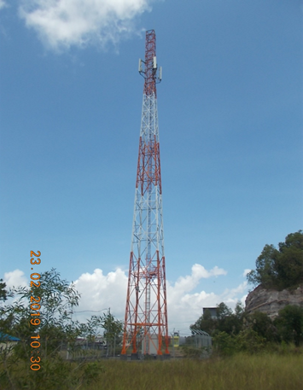
Figure 1. Self-Supporting Tower
Source: Data in research, 2019
  - Identification of problems
The main problem in this analysis is how to calculate the strengthening of the tower structure due to the addition of the structure and antenna load. The main parts of the tower structure are the main leg and bracing, so that the analysis of the profile capabilities of the two elements is the main thing. In the lateral load reinforcement planning that affects the domain is wind load, because the effect of the ratio of height and width of the structure is very large. Analysis study and design of height addition and tower reinforcement using the MS TOWER V6 program. From all analyzes, it is expected that the tolerance for additional loads can be known

  - Research Purpose and Objectives
The purpose of this study is to determine the strength of the existing tower (existing) by increasing the height to withstand the load to be added and as an effort to optimize the existing tower to increase profits.
- Finding How much load is carried by the SST tower 4 Leg 42 extend 6 m.
- Calculating the wind load acting on the gusset and antenna points.
- Modifying the strengthening structure of the tower due to Extend tower and the increase in antenna load.
- Creating a modeling design into the Ms Tower V.6 program.

2. Methodology
The research method used in this research is a survey method consisting of field data (existing) and literature studies. This type of case study research is research on the status of the object of research with respect to a specific phase of the whole person. The scope of this research can be in the form of a particular segment or part or an entire part of the object. Structural analysis in this paper uses the MS Tower v.6 program to analyze whether the structure is safe or not against the wind and to analyze whether the primary structure is strong or not withstand loads caused by the dead load of the structure and live loads and is assisted by Autocad software in the drawing results.
BTS tower structure planning is modeled with MS Tower software and is based on the following rules (code):
- SNI 1729: 2015: Specifications for structural steel buildings.
- TIA / EIA STANDARD-222-G-2005: Structural Standard for Steel Antenna Tower and Antenna Supporting Structures (Igustiany, 2011).
- AISC-LRFD - American Institute of Steel Construction
Analysis and tower design requirements for the type of Self Suporting Tower are:
- Stress Ratio Member < 1
- Twist and Sway < 0.5°
- Rotation arah X, Y and Z < 0.5°
- Displacement < H/200 (H = Height Tower)
Wind Load on Tower Structure EIA/TIA 2006
Fst=qz.Gh.(EPA)s
Wind load on the antenna EIA/TIA 2006
F_a=K_z.V^2.Gh 〖(EPA)〗_A
Melt Withdrawal Gross Cross Section SNI 1729-2015
"Nu = ϕ (Ag x Fy)" ϕ = 0,90
Net Cross-sectional Failure SNI 1729-2015
"Nu = ϕ (Ae x Fu)" ϕ = 0,75
Nominal compressive strength requirements SNI 1729-2015
"ϕPn > Pu" ϕ = 0,85
Load Combination
1.2 D + 1.0 Dg + 1.6 Wo
0.9 D + 1.0 Dg + 1.6 Wo
1.2 D + 1.0 Dg + 1.0 Di + 1.0 Wi + 1.0 Ti

3. Result and Analysis
A. In the initial planning, the tower used was the 42m tower data
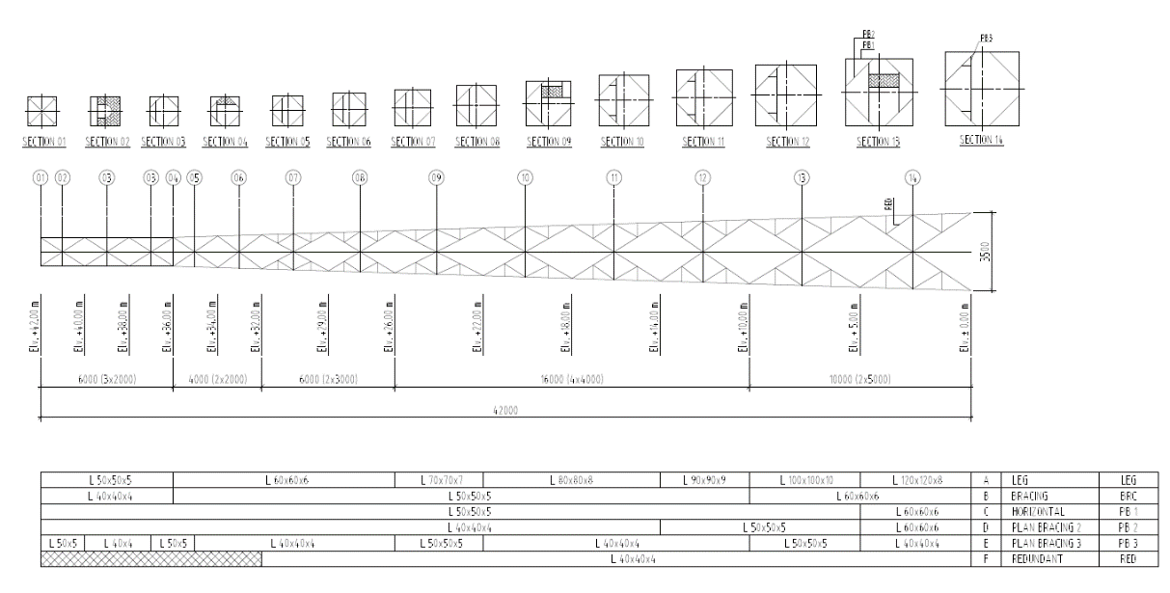
Figure 2. Outline Tower
Source: Data in research, 2020

In antenna load planning, the following specifications are used:

Table 1. Existing Antenna
No | Type | Height  (m) | Weight (Kg) | QTY | Total (Kg)
1 | RF ATR4518R9 | 39,5 | 34 | 3 | 102
2 | SH1PR-2 | 39,5 | 18,5 | 1 | 18,5
3 | RRU 3959RU | 38,5 | 14,4 | 6 | 86,4
4 | RRU 3959RU | 38 | 14,4 | 6 | 86,4
Source: Data in research, 2020

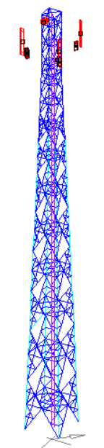
Figure 3. Modeling to MS Tower
Source: Data in research, 2020

Analysis result of existing tower:
Table 2. Analysis result of existing tower
Description | Result |  | Design Limit | Remark
Operational Wind load (84 km/h)
Twist (degree) | 0,2524 | < | 0,5 | Ok!
Sway (degree) | 0,0176 | < | 0,5 | Ok!
Displacement (m) | 0,1039 | < | 0,21 | Ok!
Rotation Antenna
Max. rotation-X | 0,2654 | < | 0,5 | Ok!
Max. rotation. -Y | 0,2638 | < | 0,5 | Ok!
Max. rotation -Z | 0,0177 | < | 0,5 | Ok!
Wind Speed ​​Plan (120 km/h)
Max. Stress Ratio
Leg | 0,345 | < | 1 | Ok!
Bracing | 0,259 | < | 1 | Ok!
Horizontal | 0,034 | < | 1 | Ok!
Plan Bracing | 0,035 | < | 1 | Ok!
Redundant | 0,207 | < | 1 | Ok!
Tower Weight | 4340.67 kg
Source: Data in research, 2020

B. Planning extend tower 42m +6 with the following data
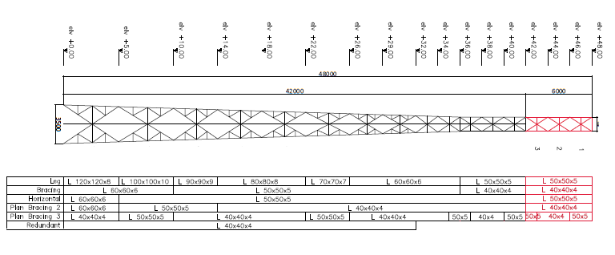
Figure 4. Modeling extend Tower
Source: Data in research, 2020

Load planning data used
Table 2. Existing & proposed antenna
No | Type | Height (m) | Weight (Kg) | Qty | Total (Kg)
1 | RFATR4518R9 | 39,5 | 34 | 3 | 102
2 | SH1PR-2 | 39,5 | 18,5 | 1 | 18,5
3 | RRU 3959RU | 38,5 | 14,4 | 6 | 86,4
4 | RRU 3959RU | 38 | 14,4 | 6 | 86,4
5 | RF ATR4518R9 | 47 | 34 | 3 | 102
6 | RRU 3959RU | 46,5 | 34 | 6 | 204
7 | RRU 3959RU | 46 | 14,4 | 3 | 43,2
8 | SH1PR-2 | 47 | 18,5 | 1 | 18,5
Source: Data in research, 2020

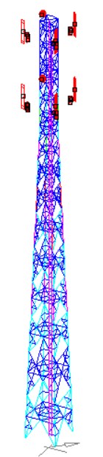
Figure 5. Modeling to MS Tower
Source: Data in research, 2020

Analysis result of extend tower:
Table 3. Analysis result of extend tower
Description | Result |  | Design Limit | Remark
Operational Wind load (84 km/jam)
Twist (degree) | 0,5645 | > | 0,5 | Not Ok!
Sway (degree) | 0,0406 | < | 0,5 | Ok!
Displacement (m) | 0,2419 | > | 0,24 | Not Ok!
Rotation Antenna
Max. rotation -X | 0,5893 | > | 0,5 | Not Ok!
Max. rotation -Y | 0,5892 | > | 0,5 | Not Ok!
Max. rotation -Z | 0,0413 | < | 0,5 | Ok!
Wind speed plan (120 km/jam)
Max. Stress Ratio
Leg | 1,189 | > | 1 | Not Ok!
Bracing | 0,61 | < | 1 | Ok!
Horizontal | 0,095 | < | 1 | Ok!
Plan Bracing | 0,078 | < | 1 | Ok!
Redundant | 0,538 | < | 1 | Ok!
Weight Tower | Kg

C. Strengthening plan
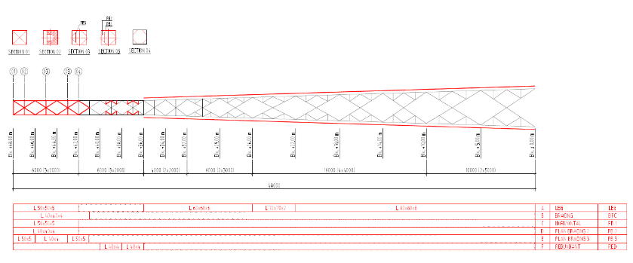

Figure 6. Modeling extend Tower
Source: Data in research, 2020

Table 4. Profile strengthening
Elevation | Profile Leg | Profile STA
+0.00 s/d +5.00 | EA 120x120x8 | EA 80x80x8
+5.00 s/d +10.00 | EA 100x100x10 | EA 80x80x8
+10.00 s/d +14.00 | EA 90x90x9 | EA 80x80x8
+14.00 s/d +22.00 | EA 80x80x8 | EA 80x80x8
+22.00 s/d +26.00 | EA 70x70x7 | EA 70x70x7
Source: Data in research, 2020

Strengthening with coupling plate
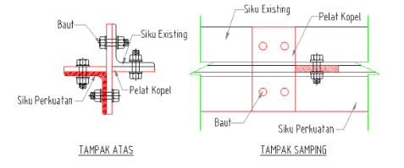
Figure 7. Modeling coupling plate
Source: Data in research, 2020

Analysis result of strengthening tower
Table 5. Analysis result of strengthening tower
Description | Result |  | Design Limit | Remark
Operational wind speed (84 km/jam)
Twist (degree) | 0,3436 | < | 0,5 | Ok!
Sway (degree) | 0,0413 | < | 0,5 | Ok!
Displacement (m) | 0,1402 | < | 0,24 | Ok!
Rotation Antenna
Max. rotation-X | 0,3633 | < | 0,5 | Ok!
Max. rotation-Y | 0,3632 | < | 0,5 | Ok!
Max. rotation-Z | 0,0413 | < | 0,5 | Ok!
Wind speed plan (120 km/jam)
Max. Stress Ratio
Leg | 0,682 | < | 1 | Ok!
Bracing | 0,729 | < | 1 | Ok!
Horizontal | 0,137 | < | 1 | Ok!
Plan Bracing | 0,094 | < | 1 | Ok!
Redundant | 0,627 | < | 1 | Ok!
Weight Tower | 6049.19 kg
Source: Data in research, 2020

Figure 8. Comparative analysis chart
Source: Data in research, 2020

Check the analysis manual
Checking the slenderness of the cross section
λ=(ky .Ly)/iy= λ < 150 (TIA-222-G)
λ =(0.8 .1163)/15.2= 61.21 < 150 (ok)
Check the ratio to compression
Bending critical stress
Terms 1, where:
$$λ ≤ 4.71\sqrt{\frac{E}{fy}} or \frac{fy}{Fe} ≤ 2.25$$
$$bending elastic: Fcr=({0.658}^{\frac{fy}{Fe}})fy$$
Terms 2, where:
$$λ > 4.71\sqrt{\frac{E}{fy}} or \frac{fy}{Fe} > 2.25$$
$$bending inelastic : Fcr=0.877.fe$$
Then,
$$4.71\sqrt{\frac{200000}{245}} = 134.57 So, 61.21 ≤ 134.57 including bending elastic$$

Determine the value of Fcr
Based on the results of the above calculations, the formula for finding the value
$Fcr=({0.658}^{\frac{fy}{Fe}})fy$
$$Fe=\frac{π^{2} . 200000}{{61.21}^{2}}=526.30$$
$$Fcr=\left({0.658}^{\frac{245}{427.89}}\right)245= 201,63$$
Determine the nominal compressive strength of the cross section
$$Pn = Fcr . Ag$$
$$= 201.63 . 480.2$$
$$= 96821,23 N= 96.82 KN$$
$$∅.Pn = 0.85 . 96.82=82.30 KN$$
Terms of press ratio
terms 1, $∅.Pn ≥ Pu$
$82.30≥ 19$ OK!
terms 2, $\frac{Pu }{Pn} ≤ 1$
$0.20 ≤ 1$ OK!
Check rod for pull
$$Pn = fy . Ag$$
$$= 245 . 480.2=117649 N=117.65 KN$$
$$∅t.Pn = 0.85 . 117.65=100.00 KN$$
Terms 1, $∅t.Pn ≥ Pu$
$100.00 ≥ 18$ OK!
Terms 2, $\frac{Pu }{∅t.Pn } ≤ 1$
$0.18 ≤ 1$ OK

4. Conclusion
After re-analyzing the structure of the 42 m tower with the addition of a height of 6m 4 feet, the following conclusions are obtained:
- In the analysis of the tower after adding the load to the antenna, propose and extend the tower, it is found that the tower condition is not strong and requires reinforcement. With a capacity ratio ratio of 118.9% or 1.189> 1.
- It is known that after the increase in the height and load of the antenna, the structural failure that experienced a structural failure was the leg of the tower at a height of 0m-40m. Strengthening the tower leg at a height of 0m-36m is reinforced with STA (Star Angle). And reinforcement for leg towers at a height of 36-40m is done by adding a redundant member.
- After the reinforcement analysis is done, the results show that the tower condition is strong, with a capacity ratio of 68.2% or 0.682 <1.3.1.
- Based on the analysis with operational wind loads (84km / hour), the reinforcement tower can withstand a maximum twist of 0.3436, a maximum sway of 0.0413, a maximum displacement of 0.1402.

References
Igustiany, F. (2011). Telekomunikasi Di Indonesia Mengacu Pada Tia / Eia-222-F Dan Tia / Eia-222-G. Prosiding Industrial Research Workshop and National Seminar, 2.

